**44-560 Advanced Topics in Database Systems**

**Assignment-04: Transaction Management**

Are you excited to know what happens when two concurrent transactions are being executed on the database?

Please follow the below steps to know by yourself.

1. Create a user and grant Connect, resource and DBA permissions to the user in SQL plus. Refer to the SQL help worksheet provided earlier.

**For creating a user:** CREATE USER <username> IDENTIFIED BY <Password>;

**For granting permissions:** GRANT CONNECT, RESOURCE, DBA TO <username>;

1. Create two different connections in SQL developer with the same user and same service name i.e., orclpdb or pdborcl (whatever you have given while installing the Oracle).

First Connection name: connection-one

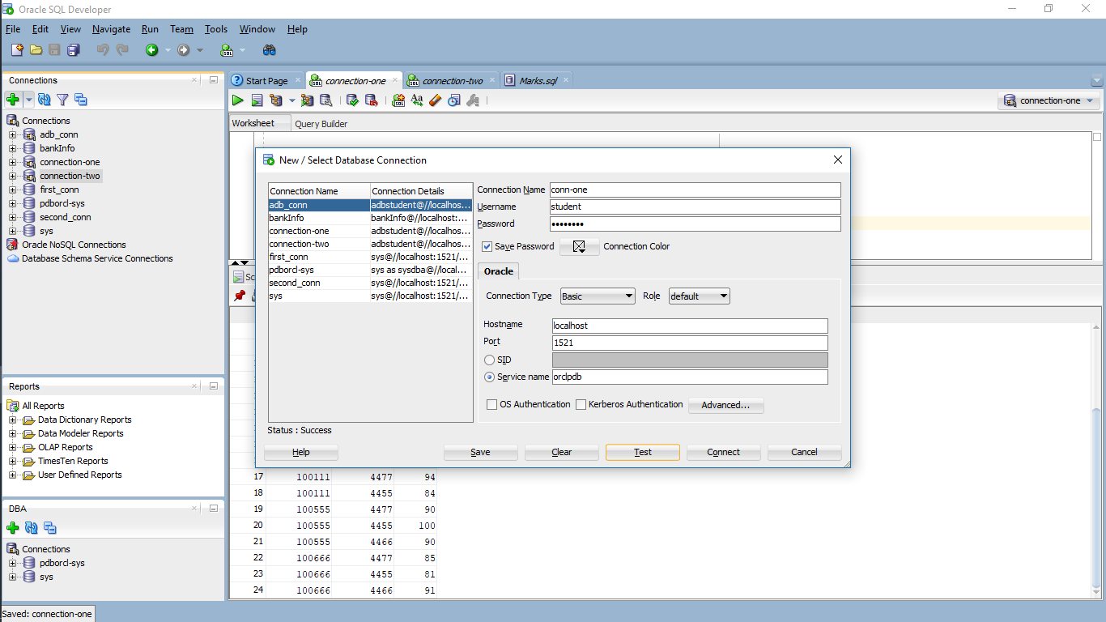

Second Connection name: connection-two

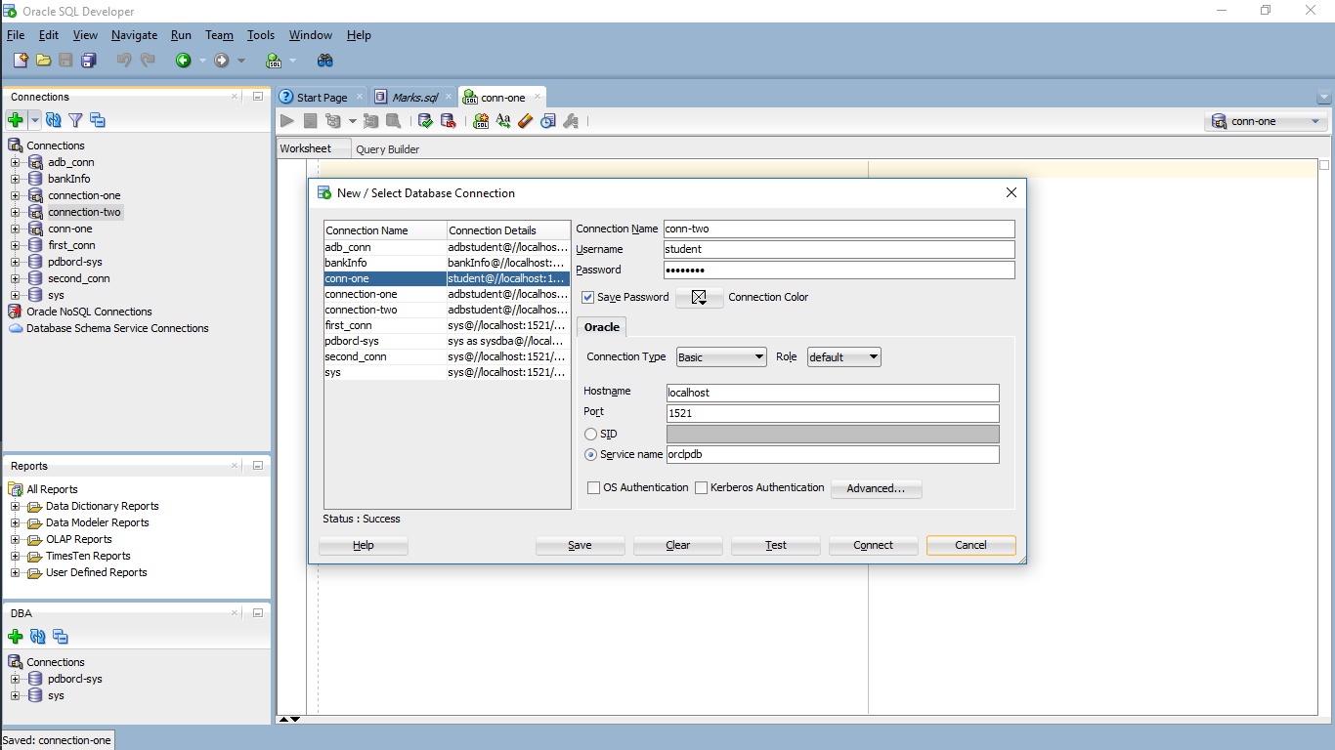

1. Open the SQL worksheets of both the connections by right clicking the connections.

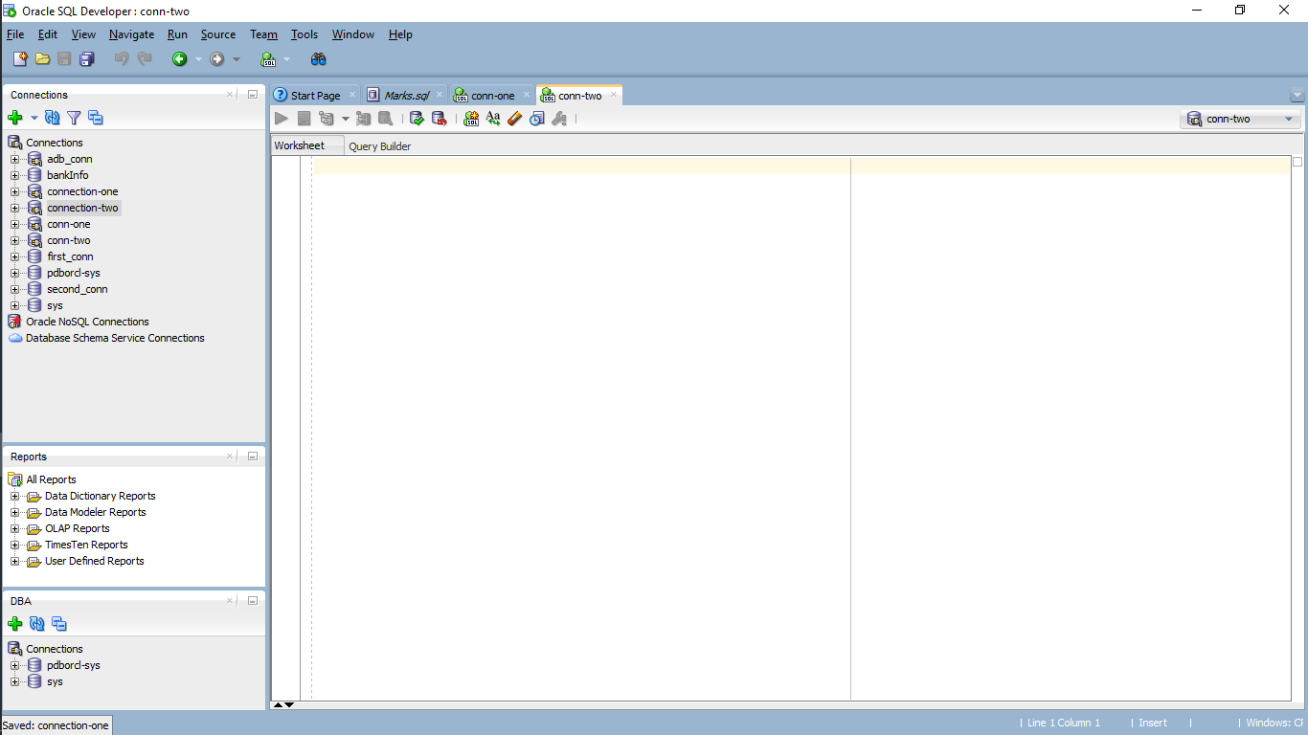

1. Open the Marks.sql file provided below and run the file line by line. Select any of the two connections that we created while running the script file.

**SQL file:**



This process results as the following screen.

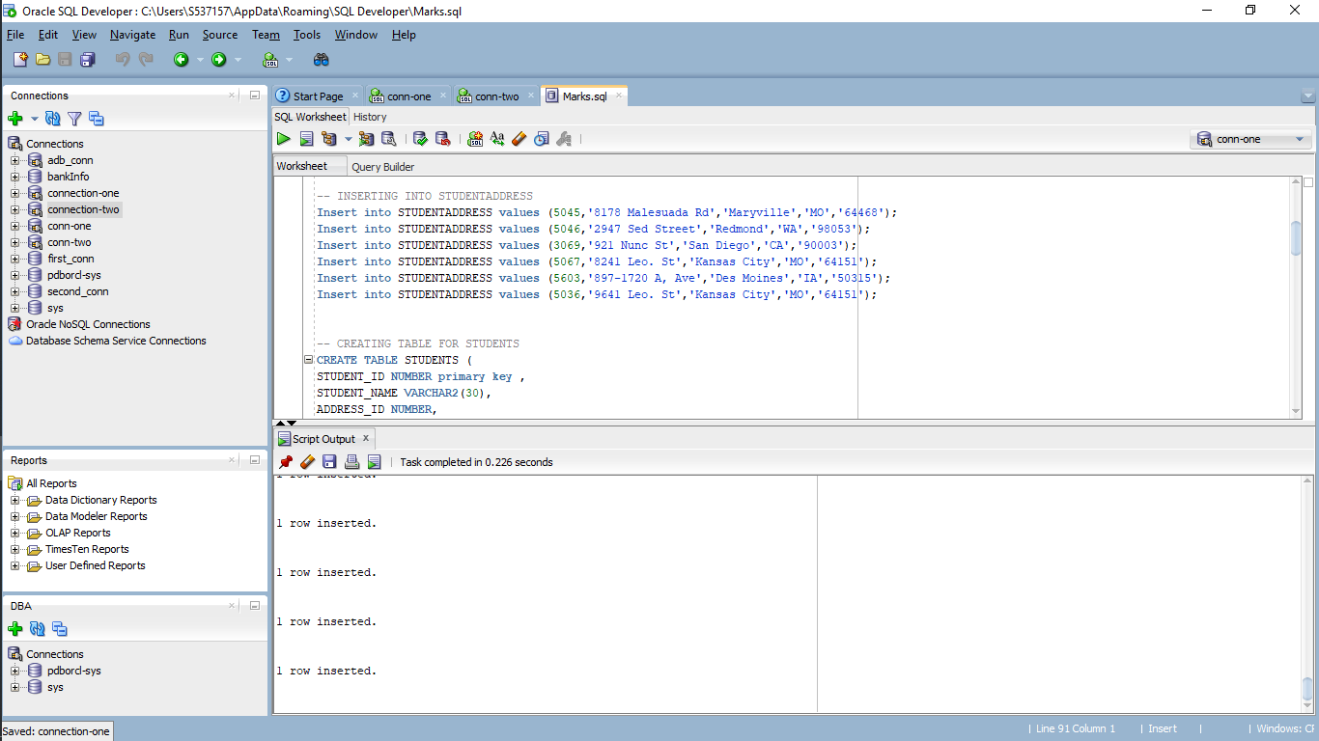

1. After running the script, you should observe same tables created in both the connections.

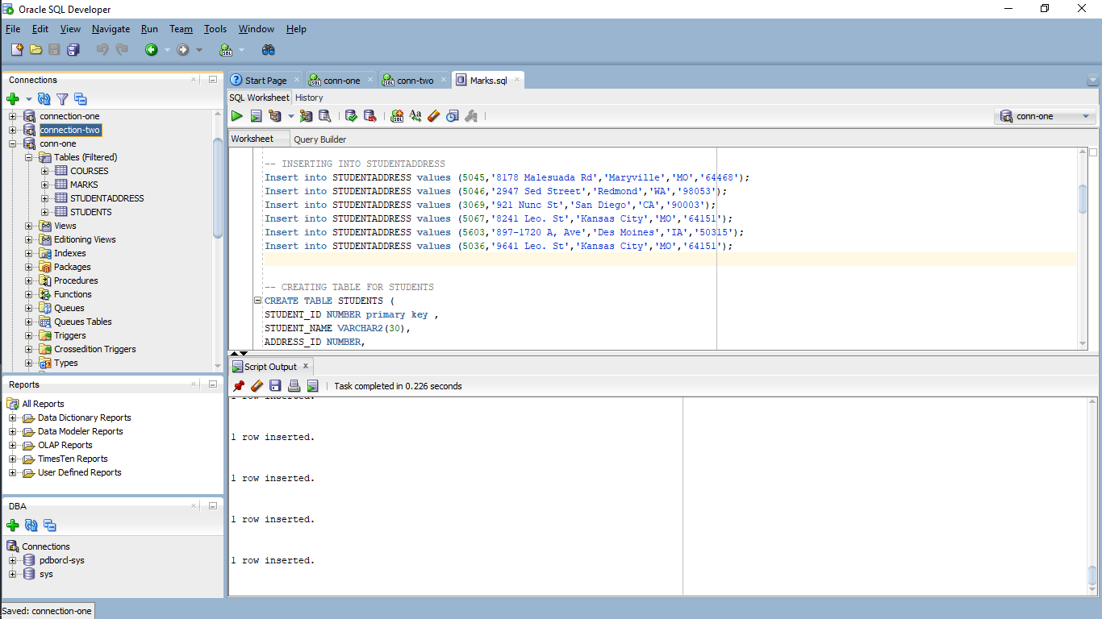 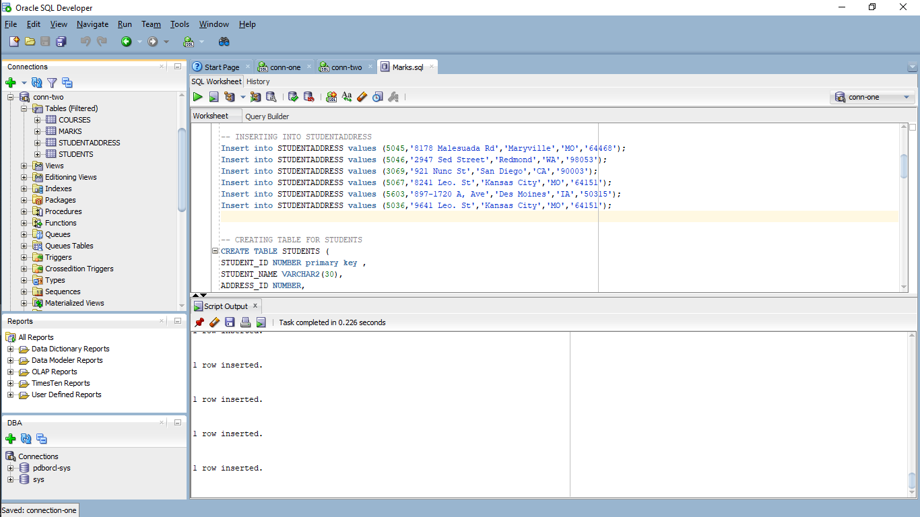

1. Now let us test by executing concurrent transactions on the same database from the two connections that we have created. We will update the marks of student with STUDENT_ID **‘100555‘** in subject with SUBJECT_ID **‘4455’** in both the connections.

In the first connection run the below queries in the order specified:

1. select * from marks;

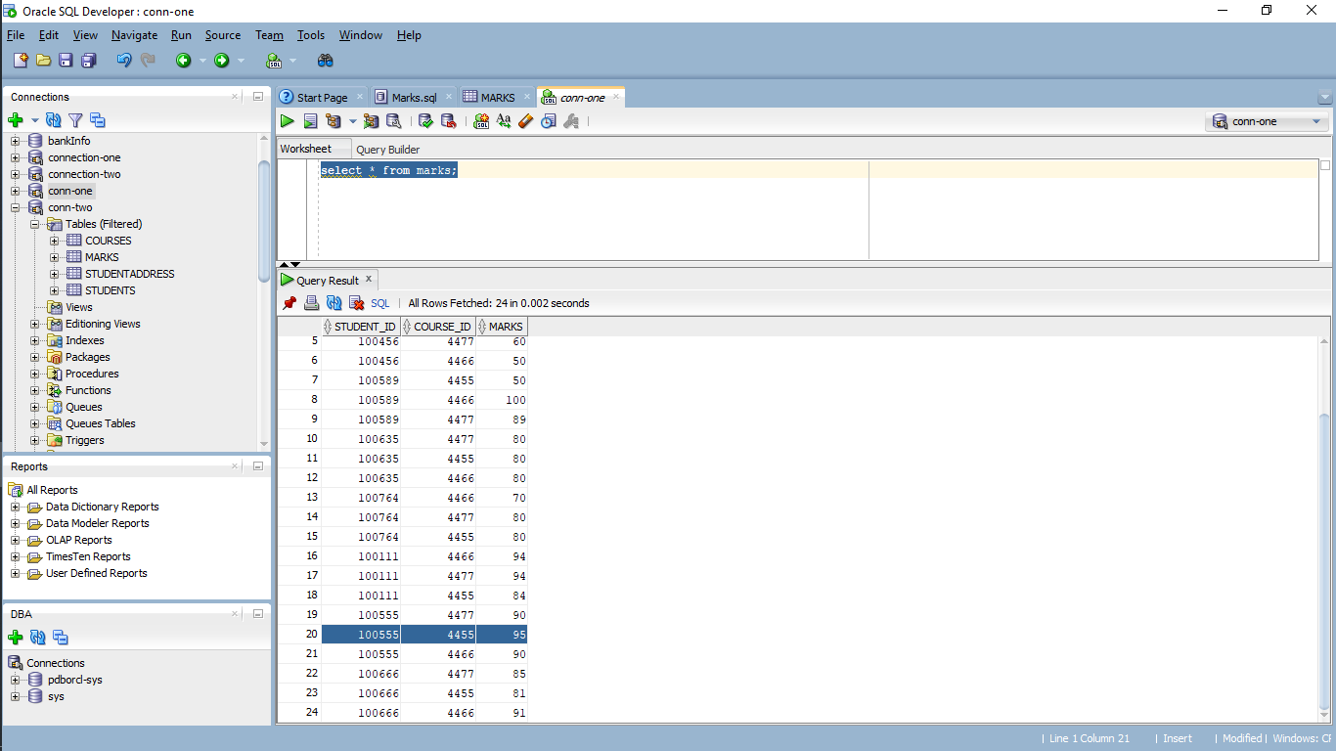

1. Now update the marks to 100 and check the description:

Use the below query to change it.

update marks set marks=100 where STUDENT_ID = 100555 and COURSE_ID = 4455; and check the data once again.

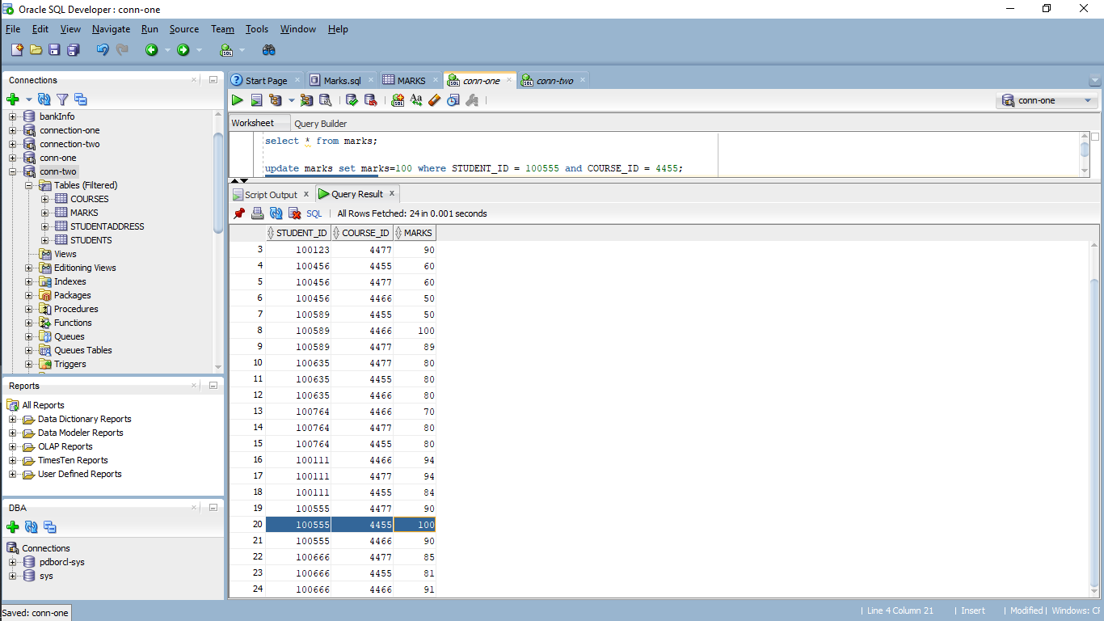

1. In the second connection run the below queries in the order specified:
2. Select * from marks;

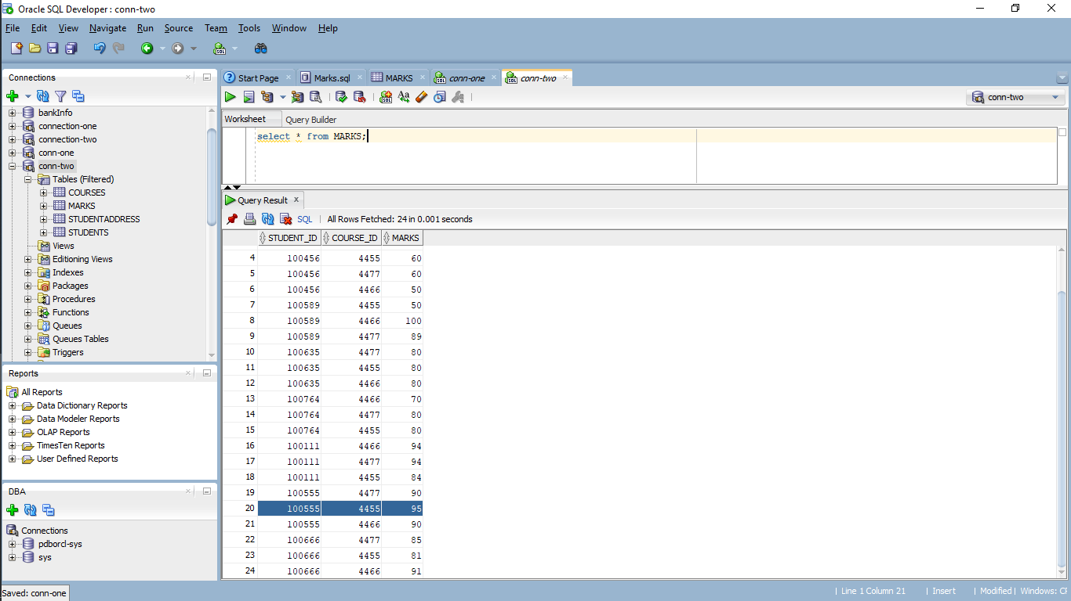

Here you can observe that the mark is still 95.

**Answer the below questions:**

1. Why the marks is still 95 even though we have updated it in First connection?
2. Update the marks to 80 in the second connect.

update marks set marks=80 where STUDENT_ID = 100555 and COURSE_ID = 4455;

You can see that the task is still executing and spinning script output.

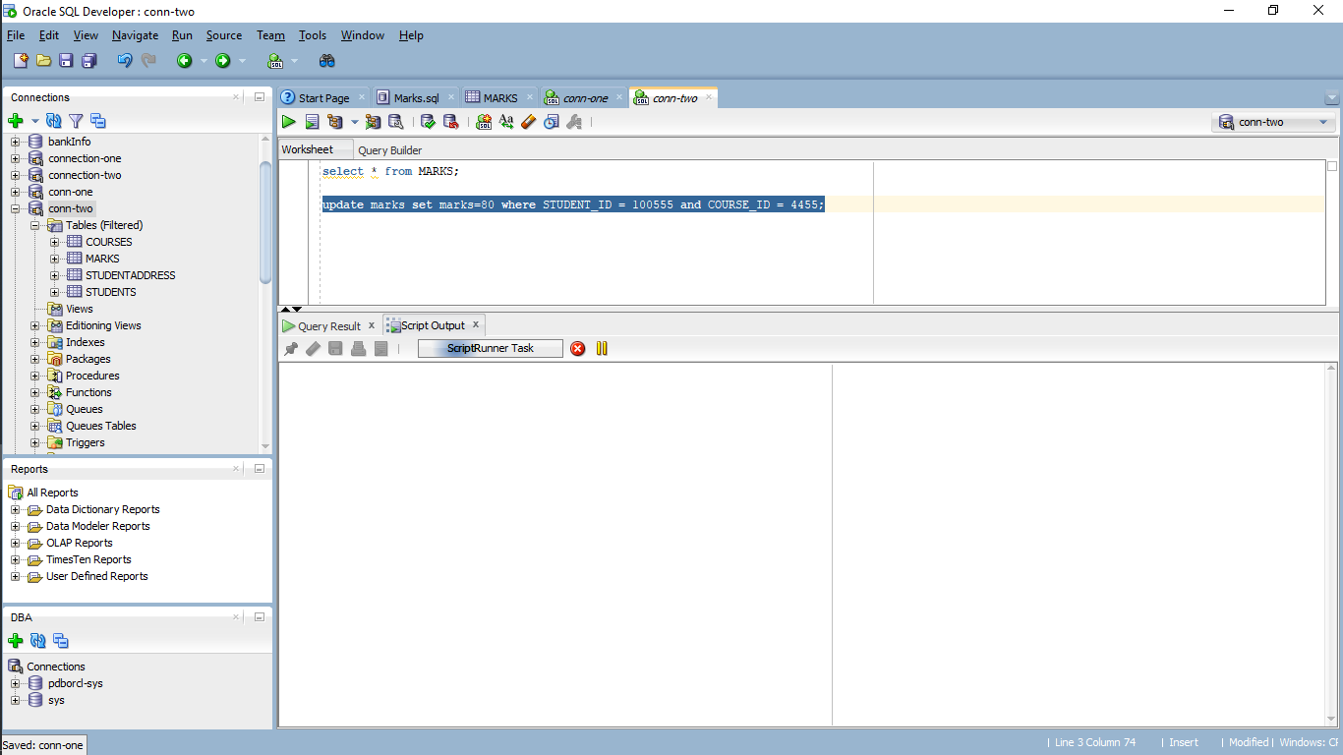

1. Commit the update we performed in first connection.

commit;

You can see that row is updated and the output in the second connection stopped spinning.

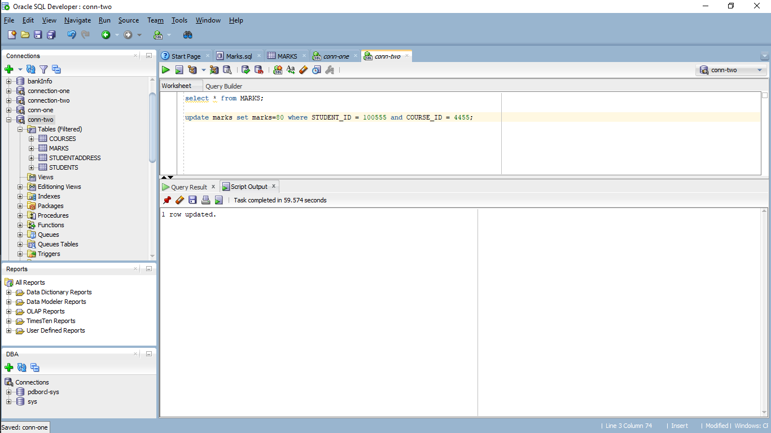

**Answer the below questions:**

1. Why was the output in second connection continuously spinning and not completing before?
2. Why did the update complete in the second connection, once we committed in the first connection?

What are the of marks for student with STUDENT_ID = 100555 and COURSE_ID = 4455 on each connection? Is the value the same or different in both connections? Why? (don’t commit in the second connection)

1. Now, in the second connection, rollback the changes and check the marks value in that connection.

rollback;

select * from marks;

You can see that the description value as “100”

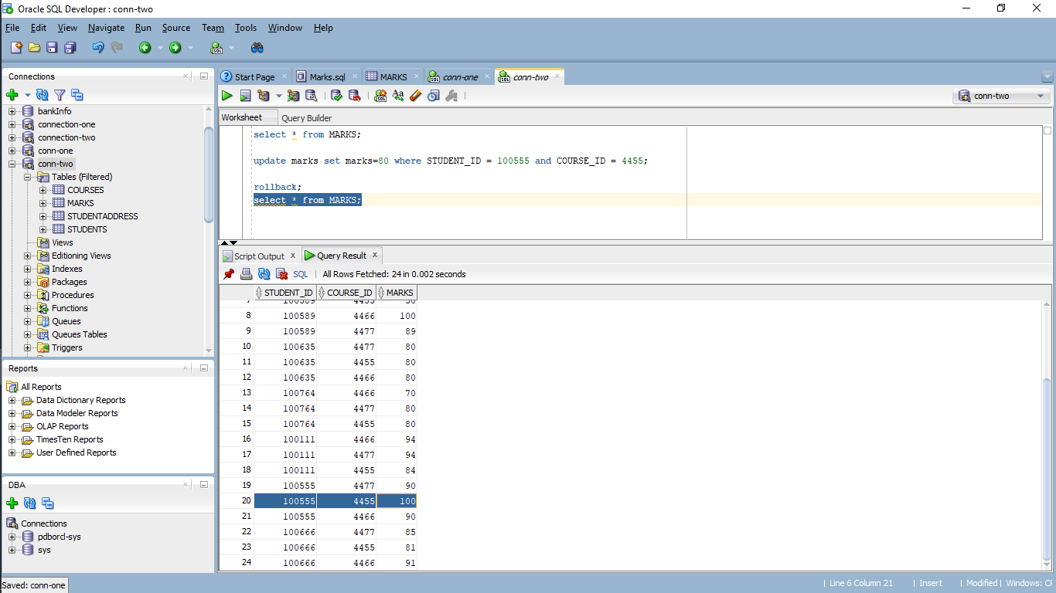

**Answer the below question:**

1. What happened immediately after we rollback in second connection?

**Few concepts of Transaction Management:**

1. In terms of a database, what is the picture below showing?

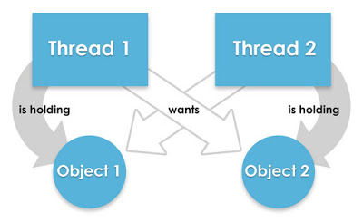

1. Consider the following transaction T consisting of T1 and T2: Transfer of 100 from account X to account Y.

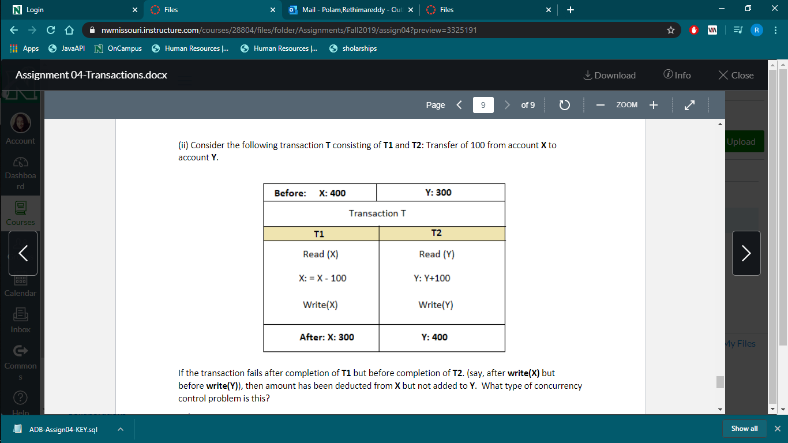

If the transaction fails after completion of **T1** but before completion of **T2**. (Say, after **write(X)** but before **write(Y)),** then amount has been deducted from **X** but not added to **Y**. What type of concurrency control problem is this?

**Submission:**

**Rename this given file with your Lastname_Assignment04 where the last name is your last name. Please highlight your answers in yellow color and submit your word doc file.**